Uploading Background Clearances

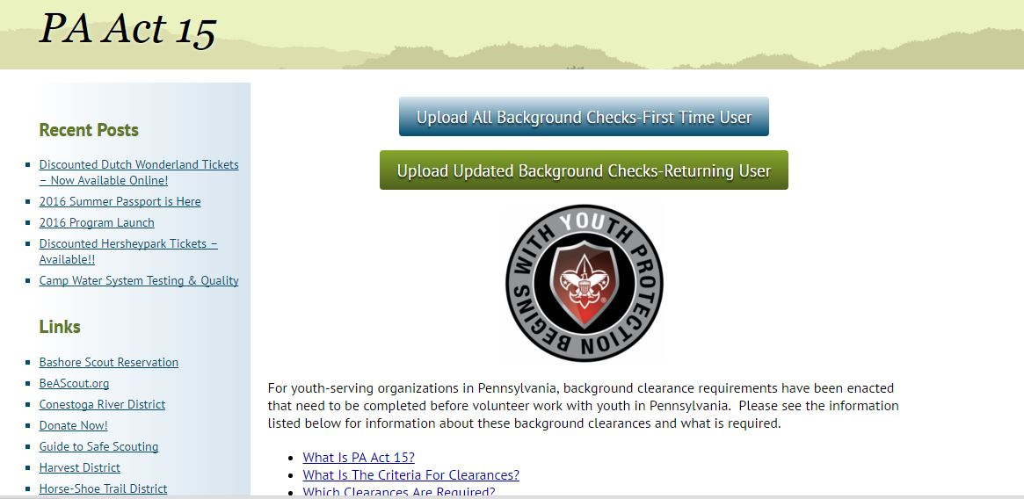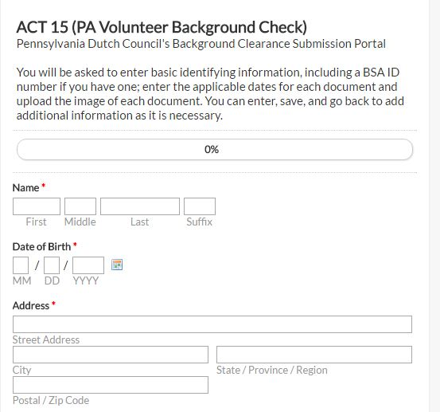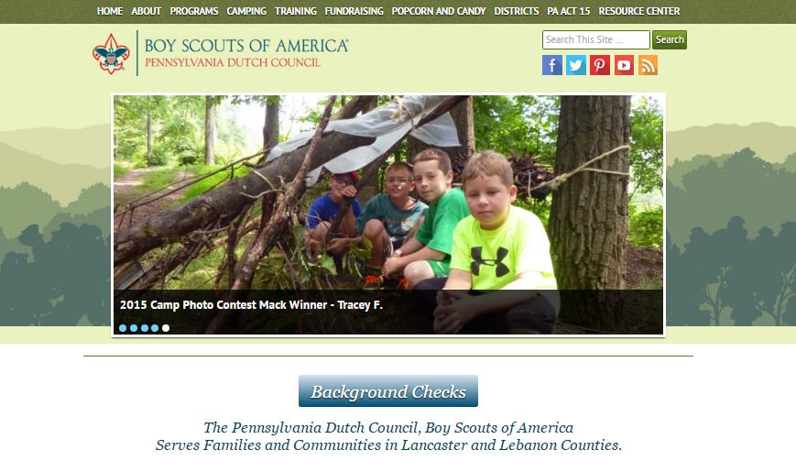

**Step 2: Select Upload.** At the top of the next page, there are two boxes. The Blue Box should be used if uploading all 3 clearances. The Green Box should be used if making updates to background clearances where you need to update only one or two pieces.

**Step 3: Enter Information**. The form will open and you will need to input: Name, Date of Birth, Address, Email, Unit Number (four digit), BSA Membership ID (if known), Volunteer Type (select all that apply), and District.

*Note: If you are uploading a clearance for someone else, the Email that is inputted is the one where the confirmation and reminder email(s) will be sent.*

**Step 1: Go to website.** Go to [www.padutchbsa.org](http://www.padutchbsa.org) and click on the Big Blue Button labeled ‘Background Checks’

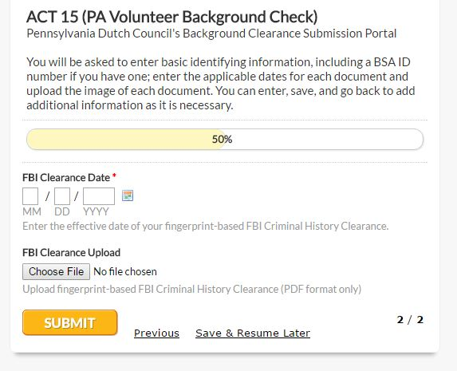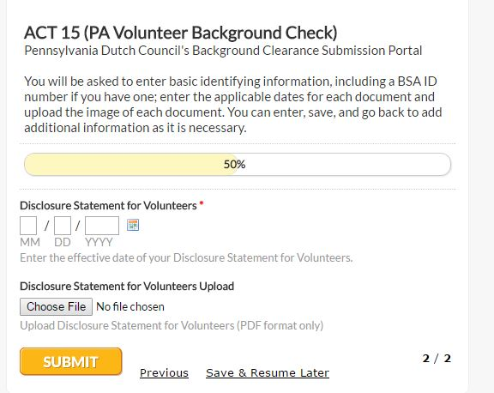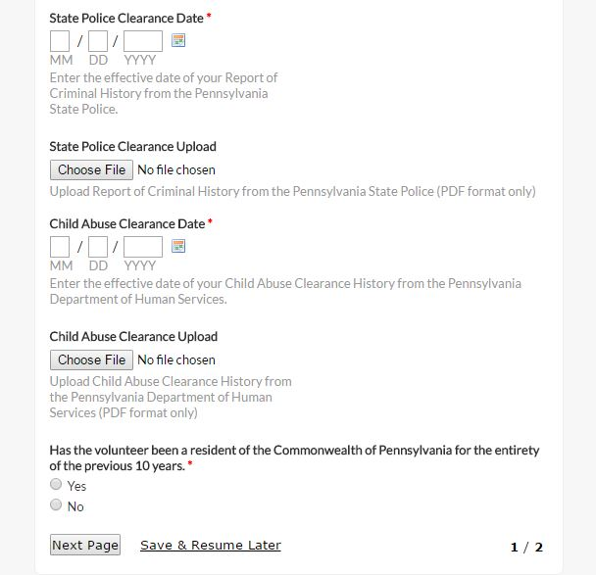

**Step 6: Receive Acknowledgement of Receipt Email**.

You will receive an email from the Pennsylvania Dutch Council acknowledging that we have received your upload. This email only serves to say that the paperwork was uploaded, but not that it was reviewed and accepted.

**Step 7: Receive Confirmation Email**

You will receive an email saying that your clearances have been received and approved. Once you have received this, please print it out and include it with your application. All new applications should include: a completed Adult Application, a signed Disclosure/Authorization Form (Page 4 of the Adult Application), proof of Youth Protection Completion, and this confirmation email.

Questions should be referred to the Pennsylvania Dutch Council, BSA 717-394-4063.

**Step 5: Upload FBI Clearance or FBI Disclosure Statement for Volunteers and Submit**. In the Date fields input the following:

Disclosure Statement-The date the form was signed and witnessed.

Result date-Located typically in the middle of the form.

Click on ‘Choose File’ under each and select the appropriate file to upload.

Then click ‘Submit’. If there is any missing information the program will prompt you to correct before submitting.

**Step 4: Upload State Police and Child Abuse Clearances**. In the Date fields input the following:

State Police Clearance-“Disseminated By” Date in the lower right hand portion.

Child Abuse Clearance-“Verification Date” on the upper right hand side.

Click on ‘Choose File’ under each and select the appropriate file to upload.

Then answer the question regarding residency. All fields that are marked with a red * are required fields. You may save your progress and return later if necessary.