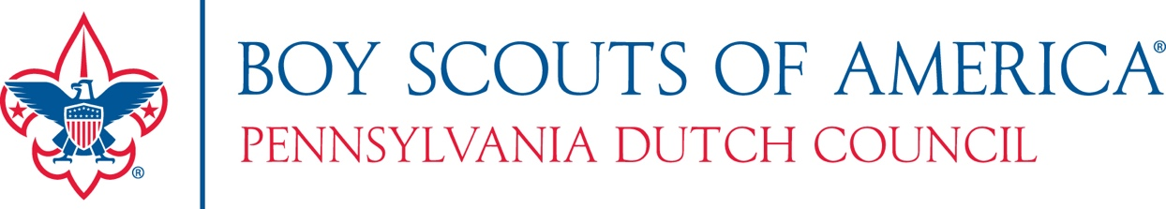

2019 Family Friends of Scouting Sample Script

(Ask youth to pass out FOS brochures)

Thank you for the invitation to share in (Unit Type and Number’s event. Example: Troop 9’s Court of Honor.)

Every family here is part of the great and growing tradition that is Scouting – and it takes leadership. So let’s start with a big round of applause for all of your volunteer Scout leaders.

This (pack, troop or crew) is part of a larger Scout family, known as the (____ District), which is a geographic slice of the Pennsylvania Dutch Council.

Each year, we take a moment to ask every family to consider making a contribution to Scouting – above and beyond what your family spends on Scouting. Your annual registration fee does directly to the National Office and any dues you pay directly supports your unit.

Like your church, there are many behind the scenes costs and your support is critical to Scouting’s ability to remain vibrant and growing.

A gift to Friends of Scouting allows the local Council to:
- Train leaders
- Host low-cost district activities
- Provide scholarships for membership, campouts and uniforms for those in need
- Offer amazing facilities like Camp Mack and Bashore Scout Reservation
- And FOS delivers all of us on-going customer service through field, support and camp staff..

There’s more information in the Friends of Scouting brochure… but ultimately, it’s about your experience. Has Scouting made in an impact on your child? Your family? Your community? You?

Only you can answer that… but I can share what Scouting means to me…

(Enter a brief personal story. Speak from the heart.)

We now invite you to participate – by pledging a gift of support for 2019.

You do that by selecting a level that works for you, filling out the form, tearing that page out – and turning it in today.

We are not asking how much you can give right now, but rather what you can give between now and the end of 2019

There are many levels to choose from, but we do invite you to consider being a Character Partner. This is a commitment of $400 a year for the next 3-years, and each year, you will receive all of the recognition items.

I would also ask every adult or family here tonight to participate at some level. Any amount helps. In fact, if every family in the council gave just $40, we would raise more than enough money to deliver Scouting. But unfortunately, only about 10% of our families participate. So, please – make a contribution to support Scouting.

Does anyone need a pen? (hand out pens)

Let’s take a few moments right now to fill out your form.
(Pause at front. Fill out your own form.)
(As you fill out yours… walk them through it)

When your form is complete, please wave it in the air and we will come by to collect it. You will receive your recognition items tonight.

(after you collect forms)

Thank you for the opportunity to share my story and thank you for supporting Scouting.

(Later – make presentation with participation ribbon. Do it later, as this will be a good reminder opportunity to turn in forms.)

