2020 Harvest District Klondike Overview

The 2020 Harvest District Klondike will be held at J. Edward Mack Scout Reservation on January 24-26, 2020. The theme for this year’s event is “Alaska: The Last Frontier” and the regular cost is $19 per person (Team Player cost is $16 per person).

Do you have what it takes to live in The Last Frontier? What would it take to survive? What skills would you need? What problems would you need to solve?

This event is designed for Boy Scout Troop and Venture Crew patrols as well as select Webelos patrols to participate in a winter scouting skills competition. Each patrol/team must utilize a team sled to move from station to station throughout the day, and at each station the patrol will compete in a skill competition or team-building task. See the sled rules posted in this document to make sure you are in conformance.

Scout patrols/teams will begin to rotate through stations at 9am Saturday morning, earning a score for their accomplishments at each stop along the way. Stations will end at approximately 3:30pm. Skills tested will include first aid, orienteering, fire building, team building, knots, Scout trivia, physical fitness, and shooting sports. Awards will be given for best score at each station, and for 1st, 2nd, and 3rd place overall. There will also be an award for “Best of Show” given to the patrol whose sled is best decorated in the theme of the event.

Lunch will be provided for all participants. Breakfast will not be provided.

Scouts BSA Patrols and Venture Crew Patrols may camp overnight at the Klondike. Tent sites will be available at no extra charge, but you must bring your own equipment as tents and cots have been removed from all sites for the season.

Cabin camping is available on a first-come, first-served basis at an additional cost of $2.00 per camper. Cabin space is limited, and troops/patrols may be asked to share cabins. For all campers, breakfast will be your own responsibility to be prepared and eaten at your site or cabin. Please clean up after yourself in accordance with Leave No Trace principles.

Friday night campers are encouraged to arrive early. Check in will be in the training center from 6-8pm.

As a cold-weather winter skills event, the Klondike has the potential to be dangerous. As part of your practice/preparation, please review cold-weather training with your patrols and leaders.

All participants must be dressed appropriately for the weather. Refer to BSA hazardous weather training for guidelines, but in general all participants should dress in non-cotton layers, with winter coats, gloves, hats, and winter-appropriate footwear. Sneakers are not acceptable footwear for snow! Scouts not dressed appropriately will not be allowed to participate. Additionally, as listed in the sled rules within this document, the Scout riding on the sled MUST WEAR A HELMET.

Parking
Signs will be posted, and participants should plan to park in the main lot on the left below the bike course and restrooms. There may be parking available at the dining hall as well. Do not plan on being able to drive to cabins or to tent sites, as we cannot predict what snow will be on the ground and what will be cleared. Tenters should plan to pack their gear to the tent sites (behind the dining hall near the health lodge). Cabin campers may try to get as close as possible to their cabins, but no promises will be made regarding accessibility.

Registration
Registrations must be submitted as a unit on padutch.tentaroo.com. All camping is first-come, first-served. On-time registration closes at 11:59PM on Tuesday, January 14th 2020. Additional fees will be applied for registrations past this date. Late registration will close at 11:59PM on Thursday, January 16th 2020.

Check-in will be at the dining hall. YOU MUST HAVE PART A & B OF MEDICAL FORMS FOR ALL PERSONS ATTENDING! One leader should check in the entire unit. Registration materials will be given to the first leader from your troop to arrive at check-in.

Event Headquarters
The Camp Headquarters and Warming Station will be in the Blair Lodge. Staff members will be staying overnight Friday in the Training Center.

Staff Members
We are looking for adults from participating troops to provide adult supervision at each site. We encourage Cub Scout Leaders to volunteer at the Klondike Stations. Webelos patrols may participate in the Klondike as a day event, but must have two deep leadership accompanying them at all times.

Webelos patrols may receive some minimal assistance from adult leaders- site leaders will approve minimal assistance at their site. Since Boy Scout and Venture Patrols may not have adult assistance or interaction, we hope that all adult leaders will participate during the event by helping to supervise stations or to distribute lunch.

Meals
Lunch will be served in the dining hall. Meals will be catered by Acorn Farms. Menu TBD, check the district webpage for updates. We will have a PBJ station for those who need alternatives. Those with needs not met by these options should email Bill Troutman at wntjr59@gmail.com NO LATER THAN 5PM on 1/4/2020. All participants - scouts and adults – should bring a drinking cup for hot liquids, and a refillable water bottle.

Rotations
Groups and rotations are planned based on number of registrants. Patrol participants must always stay together. At each station, patrols must submit their roster and attendance will be taken. Patrols will not be allowed to compete at a station without their full complement being present or otherwise accounted for.

Restrooms
The main restrooms and shower house will not be available for Klondike. Port-a-johns will be placed near the dining hall for your convenience.

Clothing
As stated, all participants must be dressed appropriately for the weather. Dress in non-cotton layers, with hats, gloves, and appropriate footwear.

Buddy System
The buddy system must always be utilized. Please review this with your scouts before arriving at camp.

Alcohol
Alcohol is always strictly prohibited. Those found with alcohol will be asked to leave the camp immediately.

Tobacco Use/Vaping
Smoking/vaping/chew is not permitted within view of the scouts. The only designated tobacco use/vaping area in camp is behind the kitchen, near the main pavilion. Anyone found using tobacco products or vaping outside of the designated area will be asked to leave the camp immediately.

Electronic Devices
Scouts should not bring cell phones or electronic devices to camp. Adults should not use their phones in view of the scouts.

Campfires at Sites
Campfire rings are provided at the sites and you are more than welcome to enjoy a fire at your campsite, please remember to: use extreme caution when building a fire; not to use accelerants; and watch for the safety of small children. Fires must be attended by an adult at all times and must be completely extinguished before leaving the site. No liquid fuels are permitted in camp.

Water and hot water/coffee/tea will be available throughout the day at the dining hall. No other water is available at camp during January. BRING YOUR OWN DRINKING CUP FOR HOT LIQUIDS AND A REFILLABLE WATER BOTTLE.

Emergencies
Siren – There will not be a siren drill at the event. If the siren sounds at night, an emergency exists. Everyone in camp must report to the assigned area given to you at check-in.
In the event of a camp-wide emergency during program time, we will activate the siren.

EVERYONE IN CAMP MUST REMAIN AT OR RETURN TO THE NEAREST STATION AND THE STATION/SITE LEADER FROM EACH UNIT MUST REPORT TO THE EVENT LEADERSHIP WITH AN ATTENDANCE RECORD.

There will be medical personnel in camp for the duration of the event. If you have a medical emergency, please contact a staff member immediately.

2020 Harvest District Klondike Sled Rules

- The sled is to be 6 feet long by 2 feet wide with a comfortable handle height (approx. 40”) for proper steering by the scouts.

- The sled is to be made entirely of wood. No metal parts (except nails or screws) will be accepted, other than the possible use of a shopping cart. The patrol may use manufactured skis or runners. The skis or runners will be the only part that may be manufactured.

- Only sleds that are used in the stations part of the event will be considered for the Best of Show competition. Sleds that fail to make it to all the stations will be eliminated from the Best of Show competition. NOTE: Minor repairs and alterations may be made during the field day competition as required if it does not interfere with the general competition).

- One scout of average size must ride in the sled from station to station. HELMET IS REQUIRED.
- One scout will steer the sled from station to station.
- All other members of the patrol will be “mushers” pulling and/or pushing the sled with properly attached rope or harness.

- Nails, screws, lashings, and glue are acceptable binding and connecting materials.

- Adults are encouraged to supervise the building of the sleds, but the sled must be built by the patrol or troop. Any sled proven to be constructed by adults will be disqualified. A Scouter – as well as a Scout – is trustworthy.

- The sled may be of any design that meets these requirements. If in doubt, contact the Activities Committee.

- In the event of a “No Snow” occasion, wheels will be permissible.

- The decision of the judges is final. If members of a patrol feel they have been unfairly treated or a mistake has been made, they must contact the event chairman immediately. Any corrections must be made at the time they occur.

- The patrol is encouraged to adorn or decorate their sleds as per the designated theme.

Violation of the rules will result in disqualification!
General Competition Rules

- Interpretation of the rules will be made by the Event Chairman. All decisions and rulings are final
- The “Best of Show” sled competition will be conducted at the completion of the stations for the day
- This is a patrol-based competition. NO ADULT/LEADER INTERACTION with the patrols during the stations (except lunch). Exceptions will be granted for disabled scouts and situations approved by the event chairman. Webelos patrols may receive some minimal assistance from adult leaders - site leaders will approve what constitutes minimal assistance at their site
- Stations missed due to a malfunctioning sled cannot be made up

- Sleds should be self-sufficient and self-contained with all materials and supplies the patrol feels may be needed for the event, including the items on the suggested list of supplies

- Patrols will not interfere, hamper, obstruct, or otherwise disrupt the movement of another patrol from one station to another

- Patrols will not move, remove, or otherwise interfere with any station materials needed by other patrols to complete specific station requirements

- Points will be awarded at stations for a patrol cheer, patrol flag, and patrol roster

- The event chairman will have final and absolute discretion in any rulings or disputes.
- Each sled will need:
Scout Handbook | Helmet (required for rider)
Patrol Flag | 10 - 6’ pieces of rope
Patrol Roster | 2 - 6’ poles  4 – 3’ poles
Patrol Cheer | 2 – Compasses
First Aid Kit | Paper
Two blankets | Pencil/Pen/Marker
Fire starting materials  (no chemicals or commercial products), tinder, and kindling.  (1 match will be supplied.) | Filled water bottles  (minimum one for each participant  4 signal flags(bright neckerchiefs, bright gloves, or bright craft flags, etc). Signal chart is included below.

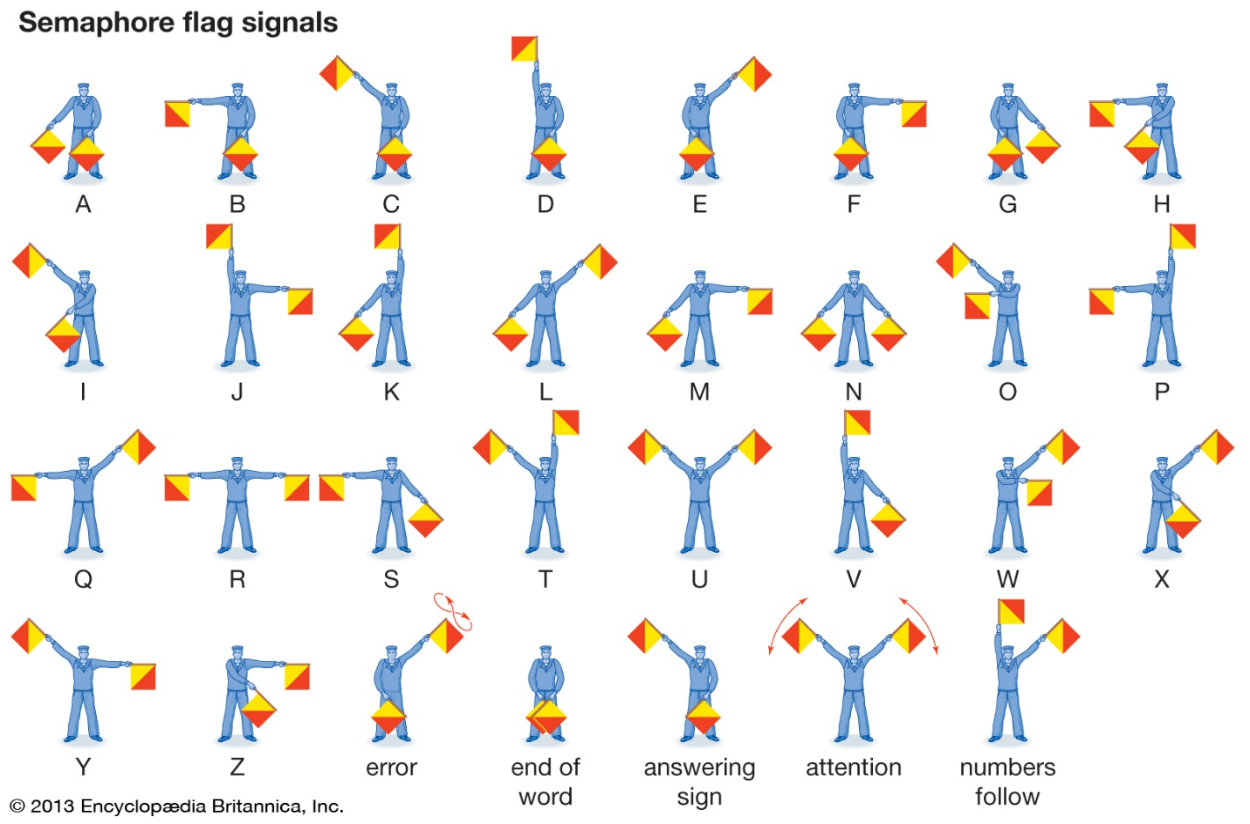

Harvest District Klondike 2020

Friday, January 24, 2020

6:00 – 8:00 p.m. Overnight Check In Training Center
10:00 p.m. Taps

Saturday, January 25, 2020

7:30 – 8:30 a.m. Staff Meeting
Check In
Announcements Flagpole

All participants should meet at the dining hall flagpole already checked in, loaded up, and ready to depart with sleds and full patrols by 8:30am Saturday morning.

8:40 Flag Ceremony and Welcome

9:00 – 9:30 a.m. Station
9:40 – 10:10 a.m. Station
10:20 – 10:50 a.m. Station
11:00 – 11:30 a.m. Station

11:45 – 12:45 p.m. Lunch Dining Hall

1:00 – 1:30 p.m. Station
1:40 – 2:10 p.m. Station
2:20 – 2:50 p.m. Station
3:00 – 3:30 p.m. Station

4:00 p.m. Awards Flag Pole

Have a safe trip home!

Patrol/Sled Roster Harvest District 2020 Klondike

Troop #

Patrol Name:

Patrol Leader:

Asst. Patrol Leader:

Patrol Members:

Troop Roster
Harvest District 2020 Klondike

Troop #

Adult Leaders

Scouts

