Hello, My name is ___________ and I am with Pack/Troop_____________ in ____________ PA.

Sorry I missed you when I was in the neighborhood. Please support me and my unit so I can ________________________________________________.

Items on lines 1 and 2 may be on hand with my unit and if so, can be delivered soon. Use the email below to order on hand product. You may also order
additional popcorn product from me via my secure sales webpage on www.campmasters.org. You can pay by credit card and the product will be shipped directly to you. You may also order Whitley’s nut products on line at www.whitleysfundraising.com to be delivered to your home. The Whitley online catalog will have product different from the items on this sheet.

Thank you so much for your support!
14 Pk Microwave Roasted Summer Corn $15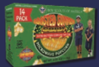
Supreme Caramel Crunch w/ Almonds, Pecans, Cashews $25
22 Pk Microwave Extra Butter $25
Caramel Popcorn Bag $10

Salted Jumbo Cashews $20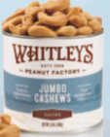
Pennsylvania Dutch Council, BSA
630 Janet Ave, Suite B114; Lancaster PA 17601
717-394-4063, www.padutch.org

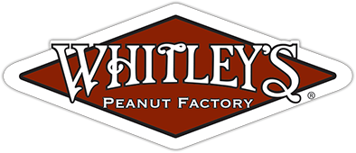
Fire Roasted Garlic & Onion Virginia Peanuts $15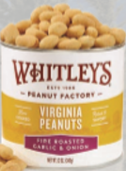
Honey Roasted Virginia Peanuts $15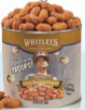
Salted Virginia Peanuts $15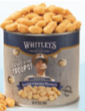

Chocolatey Treasures Tin $60
3-Way Cheesy Cheese Tin $35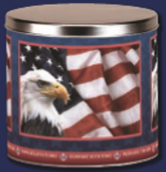
Chocolate Drizzled Caramel Popcorn $25
12 Pk Microwave Kettle Corn $15
White Cheddar Cheese Tin $15
Purple Popping Corn $10

5 Pack Gift Set $50 (Asst. includes Crabby Chesapeake Peanuts.)
Honey Cinnamon Almonds $25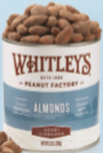
Whit’s Party Mix $25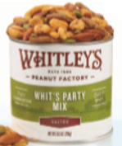
Dark Chocolatey Peanut Clusters $20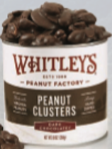
Dark Chocolatey Almond Clusters $20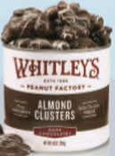
Milk Chocolatey Peanut Clusters $15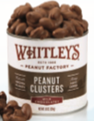
Homemade Peanut Brittle $15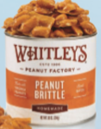

Popcorn and nut products can be ordered by contacting me via email (---------@email.com) before 10/12/20. Ordered items will be delivered after 11/13/20. You may choose to support our troops by making a $30 (ZZ) or $50 (WW) donation, and they will receive a gift of popcorn.

