Hello, My name is ___________ and I am with _____________ in ____________ PA.

Sorry I missed you when I was in the neighborhood. Please support me and my unit so I can ________________________________________________.

Popcorn and nut products can be ordered by contacting me via email (-----------------@email.com) before 10/12/20. Ordered items will be delivered after 11/13/20. You may also order popcorn product from me via my secure sales webpage on www.campmasters.org. You can pay by credit card and the product will be shipped directly to you. You may also order Whitley’s nut product on line at www.whitleysfundraising.com to be delivered to your home. The Whitley online catalog will have product different from the items on this sheet.
will have product different from the items on this sheet.

Thank you so much for your support!
22 Pk Microwave Extra Butter $25
Supreme Caramel Crunch w/ Almonds, Pecans, Cashews $25
14 Pk Microwave Roasted Summer Corn $15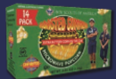
Caramel Popcorn Bag $10

Chocolatey Treasures Tin $60
3-Way Cheesy Cheese Tin $35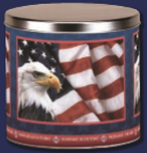
Chocolate Drizzled Caramel Popcorn $25
12 Pk Microwave Kettle Corn $15
White Cheddar Cheese Tin $15
Purple Popping Corn $10
Pennsylvania Dutch Council, BSA
630 Janet Ave, Suite B114; Lancaster PA 17601
717-394-4063, www.padutch.org

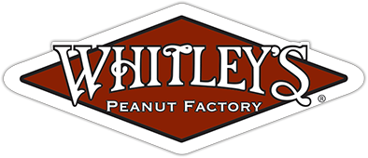
Fire Roasted Garlic & Onion Virginia Peanuts $15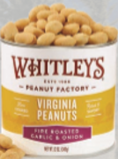
Salted Virginia Peanuts $15
Salted Jumbo Cashews $20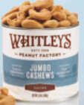
Honey Roasted Virginia Peanuts $15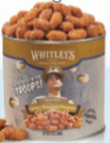

Honey Cinnamon Almonds $25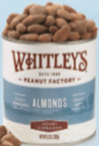
Whit’s Party Mix $25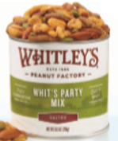
5 Pack Gift Set $50 (Asst. includes Crabby Chesapeake Peanuts.)
Dark Chocolatey Peanut Clusters $20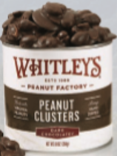
Dark Chocolatey Almond Clusters $20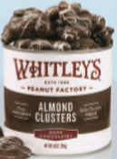
Milk Chocolatey Peanut Clusters $15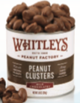
Homemade Peanut Brittle $15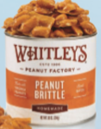

You may choose to support our troops by making a $30 (ZZ) or $50 (WW) donation, and they will receive a gift of popcorn.

