Susquehanna District Annual Nominations and Awards
Every year in June at our District Dinner we celebrate the achievements of our Scouts and Leaders. Details of the 2026 District Dinner will be announced soon:
It is not too early to start to think about nominating your unit leaders or valued parents for the following awards.
Scouter Profile Form - To assist you in collecting information for nominations, we have created this fillable PDF. You can use it to record an individual’s training, experience, and prior recognition. Do not submit the Scouter Profile; keep it for future use. (Expert tip - spouses are a great source of background information).
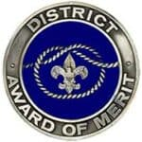
District Award of Merit –The District Award of Merit is a great way to recognize those Scouters that go above and beyond in their service to others, and the Scouting movement locally. It is the highest honor the District can bestow on one of its members.
- Click here for the District Award of Merit Nomination.
- Nomination must be submitted to Ed Carvell, edcarvell@comcast.net, no later than April 17.
Scoutmaster of the Year – if your Scoutmaster is doing an amazing job with your unit, consider nominating them for the District’s Scoutmaster of the Year Award.
- Click here for Scoutmaster of the Year Nomination Form.
- Nominations must be submitted to Marion Glasby, Marion Glasby, mkglasby@gmail.com, no later than April 17
Cubmaster of the Year - if your Cubmaster is doing an amazing job with your unit, consider nominating them for the District’s Cubmaster of the Year Award.
- Click here for Cubmaster of the Year Nomination Form.
- Nominations must be submitted to Marion Glasby, Marion Glasby, mkglasby@gmail.com, no later than April 17
Committee Member of the Year - if one of your Committee Members is doing a great job with your unit, consider nominating them for the District’s Committee Member of the Year Award.
- Click here for Committee Member of the Year Nomination Form.
- Nominations must be submitted to Marion Glasby, Marion Glasby, mkglasby@gmail.com, no later than April 17

Commissioner of the Year - if your district commissioner is doing a great job with your unit, consider nominating them for the District’s Commissioner of the Year Award.
- Click here for Commissioner of the Year Nomination Form.
- Nominations must be submitted to Marion Glasby, Marion Glasby, mkglasby@gmail.com, no later than April 17
Scouter of the Year - if an adult leader is doing a great job with your unit, consider nominating them for the District’s Scouter of the Year Award.
- Click here for Scouter of the Year Nomination Form.
- Nominations must be submitted to Marion Glasby, Marion Glasby, mkglasby@gmail.com, no later than April 17
Spark Plug Awards - Every unit has a person that provides the “spark” that keeps the Scouting program on track, whether or not they are serving in a registered position. The adult leadership of your unit may nominate one person each year to be recognized at the District Recognition Dinner by presenting them with the Spark Plug Award.
- Click here for Spark Plug Nomination Form.
- Nominations must be submitted to Marion Glasby, Marion Glasby, mkglasby@gmail.com, no later than April 17.
Den Leader Training Award - Available for Tiger, Cub Scout and Webelo Den Leaders, Tenure, training, and performance requirements are indicated on each application. You may apply for the award yourself once you have completed all the requirements that are listed in the application.
- Click here for Den Leader Training Award application.
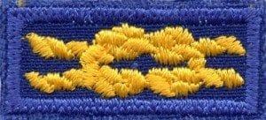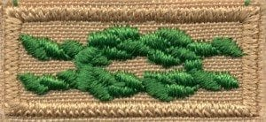
- This award can be submitted to the council office at any time, but to be awarded at the District Dinner it must be submitted no later than May 8.
Scouter Training Award - Available for registered leaders in any program. Tenure, training, and performance requirements are indicated on each application. You may apply for the award yourself once you have completed all the requirements that are listed on the application.
- Click here for Scouting Training Award application.
- This award can be submitted to the council office at any time, but to be awarded at the District Dinner it must be submitted no later than May 8.

Scouter’s Key - Available for Cubmasters, Scoutmasters, Crew Advisors, District and Assistant Commissioners and District Committee Members. Tenure, training, and performance requirements are indicated on each application. You may apply for the award yourself once you have completed all the requirements that are listed on the application.
- Click here for Scouter’s Key Award application.
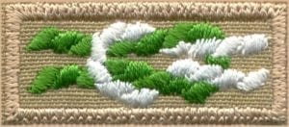
- This award can be submitted to the council office at any time, but to be awarded at the District Dinner it must be submitted no later than May 8.
Unit Leader Award of Merit - A quality Scouting experience will help keep Scouts in the program, and Scouting America created the Unit Leader Award of Merit to recognize the quality unit leaders who make that happen.
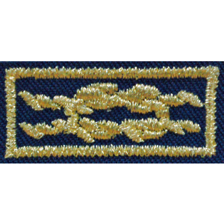
- Click here for the Unit Leader Award of Merit application
- This award can be submitted to the council office at any time, but to be awarded at the District Dinner it must be submitted no later than May 8.
Veteran Service Award - Presented for 5 years of service as a registered volunteer, and for each subsequent 5 years. You may apply for this award yourself.
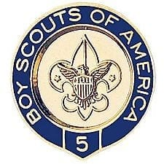
- Click here for Veteran Service Award Application.
- This award can be submitted to the council office at any time, but to be awarded at the District Dinner it must be submitted no later than May 8.

